

**JobIT (Experts Academy / Experts Prime)**

SOFTWARE REQUIREMENTS SPECIFICATION

|  |  |
| --- | --- |
| **Team Name** | **Blue Barracudas** |
| **Section** | S18A |
| **Team Members** | Andrade, Russel  Balajadia, Regina Claire  Dungan, Miguel Lorenzo  Esquillo, Lance Patrick  Ng, Francis Keith  Pangilinan, Jared Luke  Ramos, Luigi  Ramos, Michael Joshua  Sanchez, David  Syfu, Jonah  Unabia, Karl Frederick |
| **Date Submitted** |  |

**Table of Contents**

|  |  |
| --- | --- |
| 1. Executive Summary | 1-1 |
| 1. Overview | 2-1 |
| * 1. Existing Business Process | 2-1 |
| * 1. Data Requirements | 2-2 |
| * 1. Roles in the Business Process | 2-3 |
| 1. Problem Analysis | 3-1 |
| 1. Software Solution | 4-1 |
| * 1. Objectives | 4-1 |
| * 1. Characteristics | 4-1 |
| 1. User Stories | 5-1 |
| * 1. User Story #1:The User can log-in to the system through his / her account. | 5-1 |
| Appendix A - Improved Business Process | A-1 |
| Appendix B - Interview Transcript | B-1 |
| Appendix C - Sample Forms and Reports | C-1 |
| Appendix D - References and Acknowledgements | D-1 |

1. **Executive Summary**

Experts Academy is a training facility designed to help students and experts alike by developing a system of engagement / partnership with higher education institutions, whereby, Experts will provide various skills-oriented training modules / courses to the students to enhance their employability locally and abroad. They also devise education transformation to recognized industry certification as part of higher education student’s skills development training program. As well as producing graduates that are industry-ready and globally competitive and also providing equal opportunities to the underprivileged.

Other than education and training, one of the main goals of Experts Academy is to bridge the gap between students and partners, the Experts system allows them to get experts from their partner companies to teach the students the skills they require to be able to cope with the tasks that their company partners require.

One of the services they offer is Industry Placement, where Industry Placement is a partnership between the industry and Experts Academy, designed to offer high achieving students the opportunity to gain valuable experience in a professional workplace environment. An IP student can bring fresh perspectives and new ideas into your work environment.

1. **Overview of the Business Process**

*This chapter presents the company’s business process and goals as an organization/department. Included in this chapter are the following items:*

* *Description of the company's existing process and business requirements*
* *Data requirements as part of the business process, including data that are captured, stored and generated (report formats should be placed in the Appendix)*
* *Existing software or tools used as part of the business process, if any*
* *Different roles in the business process*

Notes:

* You can use subsections, e.g., 2.1 Existing Business Process; 2.2 Data Requirements; 2.3 Roles in the Business Process.
* Sample forms and reports should be included in the Appendix, for example, you can write your business process as follows:

*Weekly sales reports are prepared by each Account Executive and submitted to his/her immediate superior for review. A sample report is shown in Appendix C-2.*

The following is an example overview of the business process for a fictional company named ECTPA (adapted from INTRODB Project Specs 2009). Notice how the writing style differs across each section, eventhough the contents are repeatedly stated. Make sure your content across all sections remain consistent.

***2.1 Existing Business Process***

*Easy Call Training and Placement Agency (ECTPA) provides a complete recruitment, training and placement service to deliver well-trained and competent operators to call centers. It selects and trains operators for placement in call centers that provide outsourcing services to local and foreign companies.*

*The process starts with interested applicants accomplishing a paper-based resume (see Appendix C-1), which contain useful personal information and educational background. Once received by the Applicants Registration Department, the recruitment officer notes down the date when the application form was received and stamps it with an “application” status. The officer also assigns a unique applicant identification number to each application form for easier tracking purposes, and schedules the applicant for interview. A logbook is used to track down the list of the application forms that are received every day (see Appendix C-2). Another logbook is used to track the schedule of interviews (see Appendix C-3). The resume itself is filed in a folder that is forwarded to the Applicant Screening Department.*

*Although most Filipinos are well-versed with the English language, they must still undergo training on English Communication Skills, Customer Care, Computer Operations, and Business Operations (to know the products and services of the specific company). These trainings are provided by ECTPA to ensure that qualified call center operators are sent to the call center companies. Various training courses may be created to cover the topics provided above, and new courses may be created depending on the identified industry needs. The training officer identifies the needed training courses based on consultations with Call Center Companies. The officer then schedules multiple sessions of a specific training course, with each session accommodating up to 20 students. The schedule of courses (see Appendix C-4) is posted to enable applicants to choose their own schedule.*

*The applicant screening officer reviews each resume and conducts an interview with the applicant. After the interview, the officer decides whether to accept or reject an applicant. For accepted applicants, the officer prepares a training plan (see Appendix C-5) tailored to the needs of each applicant (i.e., based on the applicant's interview outcome, educational background and work experience). The officer sends an email to each applicant informing him/her of his application status (accept or reject) and the training plan (for accepted applicants). The status of the accepted applicant is then changed to "training".*

*Applicants with the "training" status must enroll courses specified in their respective training plan. They can choose any of the available training sessions. The applicant should receive a grade of at least 3.0 for each course stated in his/her training plan before his/her status can be changed to "ready for deployment”. Each applicant is allowed to keep on re-taking the course until he/she gets the required minimum grade, provided he/she did not receive a 0.0. An applicant who receives two 0.0 for the same or different courses will automatically be rejected (status = "reject").*

*Call Center companies who need manpower may fill-up paper-based registration forms (see Appendix C-6). The account officer of ECTPA assigns a unique identification number to each registration form. This number is then used by call center companies to notify ECTPA of job openings. For each job opening, the account officer accomplishes a job opening request form (see Appendix C-7) and marks this with a status (i.e., new, applicant selection by ECTPA, applicant screening by company, completed, cancelled). A job request that is not yet completed may be cancelled by the company or the agency.*

*Applicants in the “ready for deployment” status are selected to fill the job positions based on their qualifications (matching the requirements stated by the company). There are two steps in the screening process. In the first step, the account officer of ECTPA performs an initial selection of the required number of “ready for deployment” applicants with the specified gender. Records of the candidate applicants who are selected by ECTPA will be forwarded to the company, and their status will be changed to "company screening". The corresponding job request form's status is also updated to "applicant screening by company".*

*In the second step of screening, the call center company will send back a list of candidate applicants that it has selected. The account officer forwards this list to the employment officer, who then changes status of these applicants will then be marked “deployed”. The employment officer also prepares an employment contract, and updates the work experience (employment history) record of accepted applicants to reflect this new assignment.*

*After the contract, an applicant will be returned to the applicant pool (status = "ready for deployment") if he/she receives a rating of at least 4.0 from the company. He/She will be required to undergo further trainings (status = "training"), to be identified by the employment officer, if he/she receives a rating of at least 2.5. If the applicant receives a rating of less than 2.5, he/she will no longer be employed by ECTPA and his/her record will be marked “discontinued”.*

*The business process can be visualized in the diagram shown in Figure 2-1.*

*<insert your business process diagram here>*

*Figure 2-1. Existing Business Process*

*<Reports that are produced as part of the business process must be discussed next. >*

***2.2 Data Requirements***

*A resume (see Appendix C-1) that is submitted to the System(?) contains the following personal information namely, complete name, complete address, contact numbers (home number and cellular phone number), email address, date of birth, and gender. The resume also contains educational background, specifically the degree attained, college or university where the degree was attained, and year of completion. Furthermore, each resume is given a unique applicant identification number.*

*A job listing form that is submitted to the System contains the following information namely, job position, skills required, course required, location, work hours schedule, and work experience required. The job listing form also contains a number of slots open for the job.*

*A notification is generated by the System to notify the user about certain activities that have occurred in the System that would concern or involves them. A notification contains the the following information: type- such as new message, a reply or a appointment request, time, date and sender.*

*<Other reports that are prepared by the employees of JobIT should also be presented here.>*

***2.3 Roles in the Business Process***

*Various employees are involved in the business process of JobIT. The roles of these employees and their tasks are summarized in Table 2-1.*

|  |  |
| --- | --- |
| Role | Description of Tasks |
| *Student* | * *Uploads resume in the portal* * *Searches for job openings in the portal* * *Manages his/her account* * *Applies for a job listing* |
| *Partner* | * *Searches for Students based on their requirements* * *Sends messages and appointment requests to Students* * *Hires or rejects Students they have interviewed* * *Posts job openings in the portal* |
| *Admin* | * *Creates accounts for the Partners* * *Views information on hired students, hired applicants, and Partners.* |

*Table 2-1. Employee Roles and Tasks in JobIT*

1. **Problem Analysis**

This chapter presents the findings of the investigation on the organization’s needs and problems to be addressed by the software. (Only problems to be ADDRESSED) This section will also provide the reader with a background of the organization which is the primary stakeholder of the system to be developed. The various users and stakeholders of the software are also presented here.

|  |  |  |  |  |
| --- | --- | --- | --- | --- |
| **ID** | **Description** | **Cause** | **Symptoms** | **Impact** |
| # | What’s the problem? | What causes the problem? | How do we know the problem exists? | Why is this important? What are the consequences? |
|  |  |  |  |  |
|  |  |  |  |  |
|  |  |  |  |  |
|  |  |  |  |  |
|  |  |  |  |  |
|  |  |  |  |  |

***The section ends with the statement of the problem, need or opportunity where the software is the proposed solution (BUSINESS REQUIREMENT).***

1. **Software Solution** 
   1. **Objectives**

JobIT, a web-based Resume Portal, aims to bridge the students and the companies in the industry by letting students find jobs in a central system dedicated to Information Technology / Computer Science / Electronic Communications Engineering related skills and letting companies find certified applicants which they can hire.

This statement is followed by an elaboration of the general objective. This is done by enumerating the specific objectives of your software, for example:

*The specific objectives of the software are as follows:*

* *To provide a facility for managing, and viewing student resumes;*
* *To provide a facility for students and aspiring job seekers to find employment;*
* *To provide a facility for companies to find possible additions to their team and employ them;*
* *To provide a standard and efficient way of setting meetings and sending messages to job seekers;*
* *To provide a unified way of notifying companies and jobseekers through the resume portal, mail and/or SMS*
  1. **Characteristics**
* *Be able to handle at least 3000 users*
* *Web-based platform*
* *User-friendly*
* *Aesthetically pleasing (Good looking UI and design)*
* *Fast and responsive*
* *Good user experience (UX design and implementation)*
* *Fast and Responsive*

1. **User Stories**

|  |  |
| --- | --- |
| **User Story #1:** The User can log-in to the system through his / her account. | |
| **Estimate (Days):** | **Priority:** |
| **Pre-condition:** The Server hosting the system is running and the user has a valid account in the system. | |
| **Scenario:**   1. The User enters his / her registered e-mail address and password. 2. The User submits the entered information. 3. The System checks if the password is matched with the password associated with the e-mail address. | |
| **Post-condition:**  The User has successfully logged in. The user is redirected to the main page of his / her account. | |
| **Acceptance Criteria:**   1. Test that if the password is correct, the main menu will show up. 2. Check if the password is incorrect, the main menu will not show up and the user will be prompted for the correct password. | |

|  |  |
| --- | --- |
| **User Story #2: The Student (from Experts Academy) can create an account to gain access to the system.** | |
| **Estimate (Days):** | **Priority:** |
| **Pre-condition:** The Student must pass the exam in their respective certifications in Experts Academy (this is checked by referring to a database which keeps track if the student has passed his / her exam). | |
| **Scenario:**   1. Student enters his / her email address, password, personal info (full name, age, address, birth date, gender, marital status), school/s, skills. 2. The User submits the entered information. | |
| **Post-condition:**  The User has a new account. | |
| **Acceptance Criteria:**   1. Check if the student has passed the exam by referring to the database, if true, the account for the student is created. 2. If the Student has not passed the exam then the account is not created. A message will prompt saying “Please contact Experts Academy regarding this matter”. | |

|  |  |
| --- | --- |
| **User Story #3: The Student (not from Experts Academy) can create an account to gain access to the system.** | |
| **Estimate (Days):** | **Priority:** |
| **Pre-condition:** | |
| **Scenario:**   1. The Student enters his / her e-mail address, password, personal info (full name, age, address, birth date, gender, marital status), school/s, skills. 2. The User submits the entered information. 3. The User requests an account from the portal. 4. The System relays the request to the Admin. 5. The Admin verifies if the student has passed the exam from a recognized training centre/school/institution. 6. The Admin approves the request. 7. The System creates the account. 8. The System will send an email to the Student’s e-mail address notifying about his / her new account. | |
| **Post-condition:**  The User has a new account. | |
| **Acceptance Criteria:**   1. If the Student has not passed the exam from his / her recognized training centre/school/institution as the admin verifies it, the Admin will reject the account request made by the student. | |

|  |  |
| --- | --- |
| **User Story #4: The User can manage their profile information in order to update changes or fix mistakes.** | |
| **Estimate (Days):** | **Priority:** |
| **Pre-condition:** The User has to be logged in. | |
| **Scenario:**   1. The User edits the profile information they want to change. 2. The User submits the changes. 3. The System reflects the changes into the database and the portal. | |
| **Post-condition:**  The User’s profile information is changed. | |
| **Acceptance Criteria:**   1. Changes entered should be reflected on the User’s profile page and the database. 2. Only edited information should be changed / updated. | |

|  |  |
| --- | --- |
| **User Story #5: The Student can upload their resume in their student profile which will be visible to viewing Partners.** | |
| **Estimate (Days):** | **Priority:** |
| **Pre-condition:** The Student has to be logged in. | |
| **Scenario:**   1. The Student selects the upload resume option. 2. The Student fills up a form which will ask for job position, skills, and course. 3. The Student selects the attach resume option. 4. The Student selects a PDF-formatted resume from his/her local storage. 5. The Student submits the resume. 6. The System stores the information from the form that the Student filled up and the uploaded resume. | |
| **Post-condition:** The resume is accepted by the System and can display the resume if requested. | |
| **Acceptance Criteria:**   1. The resume is uploaded as a PDF file. 2. The uploaded file should be seen on the uploader’s profile page. 3. The form on *Scenario 2* must be filled up (required fields). | |

|  |  |
| --- | --- |
| **User Story #6: Student can search the job listings offered by the Partners to find the suitable job for him/her.** | |
| **Estimate (Days):** | **Priority:** |
| **Pre-condition:** The Student has to be logged in. | |
| **Scenario:**   1. The Student enters the keyword/s to search for job listings. 2. The System displays the job listings that have the keyword/s. 3. The Student can filter the search by company name, job position, course required by the company, skills required, location, work hours, and job experience. | |
| **Post-condition:** The System displays the job listings that matches the job filters. | |
| **Acceptance Criteria:**   1. Only open job listings should be displayed. 2. No duplicate entries displayed. | |

|  |  |
| --- | --- |
| **User Story #7: Users can choose how to receive notifications .** | |
| **Estimate (Days):** | **Priority:** |
| **Pre-condition:** User has to be logged in. | |
| **Scenario:**   1. The User goes to Account Settings. 2. The User select the notifications options 3. The User can choose to enable or disable notifications to email and/or SMS. 4. The System takes note of the User notification settings in the database. | |
| **Post-condition:** The System only sends notifications through the chosen notification medium enable by the User. | |
| **Acceptance Criteria:**   1. Notifications should only be sent in the medium/s chosen by the Student. | |

|  |  |
| --- | --- |
| **User Story #8: The Partner can effectively search applicants to look for potential employees to hire.** | |
| **Estimate (Days):** | **Priority:** |
| **Pre-condition** The Partner must be logged in. | |
| **Scenario:**   1. The Partner may / may not choose filters (location, course, skill, name, age, school) for the search. 2. The Partner selects the search bar. 3. The Partner inputs its search query in the search bar. 4. The Partner submits the search query to the system. 5. The System returns the search results to the Partner 6. The Partner will see the results to its search query. | |
| **Post-condition:** The Partner can view and select any of results of its search query. | |
| **Acceptance Criteria:**   1. Test that if the searched input exists in the portal, the results to that search query will show up. 2. Check if the searched input, the portal will display a message that the input did not have any matches in the portal. | |

|  |  |
| --- | --- |
| **User Story #9: The Partner can post job listings for Students to see and apply.** | |
| **Estimate (Days):** | **Priority:** |
| **Pre-condition** The Partner must be logged in. | |
| **Scenario:**   1. The Partner goes to the Create Job Listing option. 2. The Partner enters the job position,skills required, course required, location, work hours schedule, and work experience required. 3. The Partner enters the number of slots for the job listing. 4. The Partner uploads a PDF file that has the complete job details. 5. The Partner posts the job opening. | |
| **Post-condition:** The Students can view the job opening. | |
| **Acceptance Criteria:**   1. Test if all required fields are filled up with correct data types, the Post option will be enabled. 2. Check if at least one of the required fields are empty , the Post option will not be enabled and the Partner will be notified of the required fields. | |

|  |  |
| --- | --- |
| **User Story #10: The Partner can set appointments with the student/s to conduct an interview with them.** | |
| **Estimate (Days):** | **Priority:** |
| **Pre-condition** The Partner must be logged in. | |
| **Scenario:**   1. The Partner browses or searches through the list of registered Students. 2. The Partner selects a Student from the list. 3. The System displays the information and resume of the Student. 4. The Partner selects Set-Appointment on the profile of the selected Student. 5. The Partner sets the date, time, and place of the appointment. 6. The Partner may opt to add a message. 7. The System will send the notification to the chosen Student. | |
| **Post-condition:** The Student receives an appointment notification. | |
| **Acceptance Criteria:**   1. Notification/s should be sent only to the selected Student. 2. Appointment notifications received by the Student should include the correct information specified by the Partner. | |

|  |  |
| --- | --- |
| **User Story #11: The Partner can inform applicants if they are hired or rejected to to let them respond accordingly.** | |
| **Estimate (Days):** | **Priority:** |
| **Pre-condition:** | |
| **Scenario:**   1. The Partner decides if the applicant if he/she is hired or rejected. 2. The Partner selects to hire or reject the applicant. 3. The System will generate a default message response. 4. The Partner composes the message regarding if he / she is hired or not. 5. The Partner submits the message. 6. The System relays the message to the Student. 7. The System notifies the student regarding the message. | |
| **Post-condition:** The Student receives a notification through his / her preferred method (e-mail or SMS) and his / her account in the System. | |
| **Acceptance Criteria:**   1. Test whether the chosen applicant is correct or not. 2. Test whether the chosen applicant has been interviewed by the Partner. | |

Notes:

* The scenario should provide the sequence of interaction between the user and the system based on valid inputs.
* There should be no mention of interface details (such as screen, buttons, clickable, presses) or platforms (web) anywhere in the user story (including pre- and post-conditions, scenario and acceptance criteria).
* Pre-conditions must state the constraints (on user roles, data availability) that must hold true before the user story can be performed.
* Post-conditions must state the outcome (on data, process, and user state) that will hold true when the user story has been performed.

|  |  |
| --- | --- |
| **User Story #12: The Admin can log-in to the system to have access to the system.** | |
| **Estimate (Days):** | **Priority:** |
| **Pre-condition:** | |
| **Scenario:**   1. The Admin enters a special series of key codes. 2. The System shows a special log-in page. 3. The Admin enters the password. | |
| **Post-condition:**  The Admin has logged-in to the system. | |
| **Acceptance Criteria:**   1. Check if the entered password is correct, if true, the page for the Admin shows. 2. If the entered password is incorrect, the system promts to enter the correct password. | |

|  |  |
| --- | --- |
| **User Story #13: The admin can create partner’s account to give them access to the system.** | |
| **Estimate (Days):** | **Priority:** |
| **Pre-condition:** The Admin must be logged-in in the system. | |
| **Scenario:**   1. The Admin enters the company’s name, industry, and password. 2. The Admin submits the entered information. | |
| **Post-condition:**  The Admin has created an account for a partner. | |
| **Acceptance Criteria:**   1. The valid account has been created. | |

kindly check

|  |  |
| --- | --- |
| **User Story #14: The Admin can view a list of information of hired students, hired applicants or partners to check the data in the system.** | |
| **Estimate (Days):** | **Priority:** |
| **Pre-condition:** The Admin must be logged-in in the system. | |
| **Scenario:**   1. The Admin selects which set of data to view. 2. The System shows a list of data of the selected filter. | |
| **Post-condition:**  The Admin can view the list of data. | |
| **Acceptance Criteria:**   1. The Admin can only view the data being listed. | |

**Appendix A – Improved Business Process**

*This chapter presents the improved business process when the proposed software solution is implemented. This visualizes how the software solution benefits or affects the current business process.*

**Appendix B – Interview Transcript**

**Experts Interview 1 (January 27, 2015)**

**[B] – Blue Barracudas [I] – Interviewee**

**I – Ano course nyo?**

**B – Computer Science po**

**I – Sa La Salle?**

**B – (nods)**

**I – Ano na kayo? Third year?**

**B – Second year po.**

**B – Verify ko lang po- sa web portal, yung main process nya yung mga students o passers ay mag uupload ng resumes tapos i-viview ng mga companies na may access sa website?**

**I – Basically ganun pero hindi siya mismong PDF lang. Yung main process nun, Everytime nakapasa yung student, magreregister siya at sa admin part, saamin, pwede namin i-verfiy gamit ang database naming at pag na-verify namin, manonotify siya via email or text or sa portal. So para siyang Jobstreet, ganun na ganun yung concept niya.**

**B – Sir, pwede ba i-record kasi gagawa po kami ng transcript.**

**I – Sige.**

**I – Ano yung subject yan?**

**B- Software Engineering**

**I - Pero anong programming language ginagamit?**

**B – Java.**

**I – Java?**

**B – Anything goes naman saamin pero preffered namin is Java. Yun ang tinuro saamin.**

**I – Kasi ang sinisimulan naming dito is through web kasi kinakailangan naming i-deploy online.**

**B – May subject naman kaming web development.**

**I – So possible na yun ang gamitin?**

**B – Possible po gamitin namin ay web.**

**B - First question po namin: Do you store the resumes in a database?**

**I – Yes.**

**B – Kapag let’s say may nag-request, do you send by batch or specifics like kapag sinabi: I want this student from this university? May nag-mention kasi before may mga companies na nag rerequest sainyo ng mga resumes, do you send it like 1-100?**

**I – Ah, filtering?**

**I – Hindi po, parang bawat company binibigyan lang naming ng access sa mismong resume portal.**

**B – Currently po since wala pa pong portal?**

**I – Yung mga studyante ang nagbibigay saamin ng resumes tapos kami na naguupload o kung pwede, may mga accounts yun mga students na sila maguupload at mag-edit ng profile nila.**

**B – Yung sa web portal sir?**

**I – Oo.**

**B – Pero ano po current nyo?**

**I – Ah, current! Current process ay parang sinesend nga like in a file.**

**B – So walang existing?**

**I – Walang existing. (Referring to resume portal/system)**

**B – Ah wala po? Ok, let’s move on.**

**B – Second question: Do you want the system uhh, Do you want the companies to view them for free? Or may subscription?**

**I – Sa ngayon, free kasi for 6 months, parang dry run yan eh so parang testing period siya. So after 6 months, if the feedback of the system is maganda, then dun kami maglalagay ng subscription para ung mga ibang companies pwedeng mag-partner dun sa let’s say sa experts. Pwede yun nga preferably may subscription pero for the first 6 months, free.**

**B – Follow-up po: Are there different types of subscriptions?**

**I – Meron diba? Sa marketing natin which is the company na let’s say magreregister sila for free, ang access lang nila is viewing lang. Wala silang access to posts or pag nag job posting sila, we are hiding stuff like that kung baga yun access is the company lang pagka free. Pag may subscription, yun na iyon, full access na siya sa system.**

**B – Next question: Are there any requirements for the students para mag submit ng resume?**

**I – Yes, they need to pass the CCNA exam.**

**B - Is that a good entrance-**

**I – Yes kasi CCNA, uh ang CCIE yun eh yun yung basic requirements ng job portal for you to be considered sa database ng job portal.**

**I – Yung mga students lang kasi ng mga experts kung baga parang priority ng magkaroon ng account para sa job portal o resume portal.**

**B – In the future po, mag oopen pa kayo for other students?**

**I – Oo, preferably kung possible pero ngayon meron tayong ibibigay na accounts sa students kasi… diba?**

**I – Pwede rin. Ang basic kasi nun ay register lang sila nang register. Parang tayo ang mag aaprove.**

**B – So pag nag register, for approval pa po?**

**I – For approval pa.**

**B – So in the future, open kayo for other students, bibigyan ba ng edge ung students pag nag search ng requirement sila ung nasa favor ng search results?**

**I – Oo, sila yung nasa taas. Priority sila pag alumni sila ng experts; priority sila sa lahat like search, list of new passers, new registered account sa portal. Number 1 dapat sila.**

**B – Pwede ba i-update ng mga students ung resume? If so, when and how many times?**

**I – Actually, hindi na hawak ng… For you, nakita ko na kasi ung scenario na update lang ako nang update. For me, ang sasagot ko doon ay hindi na hawak ng system iyon so its beyond the jurisdiction of the system pero and pwede natin ilagay doon is kailangan ganun yun to verify na nandun sila, linked dun sa company. So let’s say isang beses lang ako nag-work pero nilagay ko marami na pala akong work. Wala tayong control.**

**B – So wala muna tayong restrictions?**

**I – Sige, pwede kayo mag come up ng idea kung paano mag rerestrict yun pero sa ngayon, wala munang restrictions.**

**B – How many students or passers are you expecting to be using the portal, estimated?**

**I – Sa ngayon? Probably around 3000 students**

**B - Any requirements para sa mga companies to b able to make an account?**

**I - Memorandum of Agreement, tapos parang tayo yung bibigay ng access at user accounts. Lets say parang kayo yung company at lumalapit kayo saamin.- Kasi yung mga companies parang dapat partner sila sa mga experts, di lahat ng companies may access dun sa portal. Dun na papason yung subscription. And then memorandum of agreement. Kumbaga initially kapag nag-agree na, gagawin na naming yung account ng company and then parang generated to code yung password pero username nila yung ano – lets say companyA@company.com so ayun, puwede nalang i-edit, palitan yung details nila at password.**

**Bali tatlo ang gagamit nito, si job seeker, company, si admin. So, kami kontrolado naming yung si job seeker at si company. Sila parang sila ang client naming, pero different account, different user type.**

**B- Ano po yung ginagamit ninyong technologies for this portal?**

**I – Currently, dinevelop naming yung initial database, yung parang yung flow system sa php, at my sql na database. Natuwa siya oh, yes madali to! Hahaha**

**B- hahahaha**

**I – Bakabukas tapus na ah? Hahaha. Boot strap yun, boot strap.**

**B- So yung first po, mag uupload yung student ng resume when they pass, tapos yung resume nila stored in the database, then for viewing nap po yan ng mga company?**

**I – yeah**

**B – yung hiring po rin ba through the website rin ba?**

**I – oo, throught the website. So initially kayo na yung passers at ako yung company, tapos nakita niyo jobpost ko. I need 3 CCNA’s. Kayo yun, nag-apply kayo sakin, and then manonotify ako na nag-apply kayo for this job position. And then I’ll view yung resume niyo and then pagnagustuhan ko, magsesend ako ng lets parang appointment na date saating dalawa. So dun na sesend. I-sest ko yung time, yung date kung saan at yung location, and then ma fefeed sayo yun. Puwede mong i-decline, or reschedule, and then accept. Mainly yan yung transaction na ginagawa from registration to company na nag-job post, tsaka si job seeker nag-apply, and then si company nag-view ng resume mo and then nagustuhan, then sesend na yung appointment. Then yun na, accept or decline tapos reschedule.**

**B – So si company po, si student aaply siya for the company diba?**

**I – hmh. *nods\***

**B - Si company pwede siyang magchoose na siya mismong mag-aaproch sa student.**

**I – Puwede rin. Yan yung isang mismong feature na kapag may subscription ka.**

**B – Ahh, okay.**

**I – Kapag may subscription ka, yung post, yung popost ka ng job post mo, kumbaga lahat ng functions ng portal nandun. Pagkawalang subscription, free lang, more on viewing lang. Puwede niya sigurong tignan yung profile ng resume ng mismong student pero limited lang makikita niya, lets say name lang, pwede yung ganun.**

**B – okay so yan yung first, so next po yung 6 months free muna yung job portal. So yung mga companies na yun full access?**

**I – full access.**

**B- okay, tapos yung full access, kita lahat, mga functions, features lahat available para sa mga company?**

**I – hmh**

**B – tapos yung free na yung client na hindi nagbayad sir, pang view lang ng resume, at incomplete details, at di lahat ng funtions available?**

**I – oo, at di lahat ng functions available, viewing lang siya.**

**B- Tapos next, yung makakaregister lang sa portal is yung students na naka-pass, automatic yun?**

**I – for approval.**

**B- tapos mga students nay yun may priority sa mga search results.**

**I - *nods\***

**B- open to other students rin po diba?**

**I – op open to other students.**

**B – So for a company to register in the portal, an MOA is required?**

**I – yes.**

**B- Then the account is given by the experts?**

**I – hmh *nods\***

**B- Generated by code password?**

**I – yes. Hmmm featues. Meron kaming ginawa na plain text lang siya so pakita ko sa inyo.**

**B- Sige sir.**

**I – yung resume portal sa kanilang payment center, di ba puwedeng other choices.**

**I – Puwede rin, pero mas favorable ying isa.**

**B- di ba mas baias sa advantage experts sa nagpoportal? Puwede rin bang other training centers tignan ang resume portal?**

**I – So far ang resume portal isa palang ang training center.**

**B – so for the first 6 months kayo lang po ang may access dun, wala pa pung students from other training centers**

**I – Acctually puwede na kaagad eh**

**B- Sir, since yung other students from outside your training centers puwedeng maka-register kailangan po bang accredited ang training center, or kahit sino puwedeng makapost po?**

**I – sa ngayun kasi for students lang ni experts.**

**B- okay.**

**I - para sa mga enrollees na experts, maron kaming bibigay na code na kapag magreregister sila ang may priority na makikita ng mga companies.**

**B- So code based nay un para malaman?**

**I – code based, para kapag magreregister siya, parang username, password, tapos meron pang isang field na pwede lagyan. Di naman required, pero kapag nilagyan sila yung may priority- Puwede ba na wag muna natin lagyan ng feature na para sa mga ibang studyante? dito lang muna. Pero nakaredy na yung registration page natin tapos ganun nalang.**

**B- So for now, required yung code?**

**I – oo.**

**B – sa side po ng mga students from other training centers, free na ba yung registration nila?**

**I – Oo. So initially ito yung na come up naming na plano sa jobIT. So, employers homepage, ayun siya.**

**B – Puwede pong picturan sir?**

**I – sige sige!**

**I – So initially ito palang na ooverview lang naming na parang magiging interface ni employer, pero madadagdagan naman at magiging complex yung ano eh. So yun kumbaga ito yung main na feature niya. Makikita niya yung mga applicants, ito ang mga nag-apply para sa jobpost nila at magrarandom lahat. Madami na agad makikita sa pinaka-homepage ni employer, Tapos itong mga names na ito clickable siya na kapag cinlick mo siya, makikita mo na yung mga details nung student. Kumbaga linked sa profile. Mas okay sana kung randomized siya pero yung priority is yung students ni experts. Priority yun, pero random.**

**I – Yan merong tayong hire applicants tsaka mga settings. Then lets say cinlick natin yung “John Doe” Makikita nayin yung information niya at yung resume niya mismo. And then lets say na gustuhan naming resume niya, lets set an appointment.**

**I – Yung dito, ito yung parang meron tayong i-seset na table sa registration page. So ito yung parang information nila. Dito sa resume puwede tayo mag upload ng documents, mga pdf file nandito sa documents na full details yung nakalagay, dito mas specific lang nakalagay kumbaga yung priority niya na information na gusto Makita ng client parang ganun.**

**B – Yung over views sa person?**

**I – Parang cover page para sa resume niya.**

**I – Si sir Carlo pala**

**B – Morning Sir!**

**B – So sir, since in the future yung mga companies na di naka subscribe sa web portal, yung personal information lang po yung makikita?**

**I – Oo, pwede. Pero di pwede yung documents. Lets say hanggang dito lang. Kasi initially pwede na niya macontact yan kahit mamanual niya eh. So yung contactidails dapat matago natin yan. Unless masest niya yung appointment.**

**I - May message, parang generated na kaagad. Either for exsample “hi this is JobIT , we are proud to tell you that this company would like to set an appointment with you in this date and time and place” ganun.**

**I – Puwede rin kayo magcome up ng sarili ninyong solution tapos i-sabi niyo saaminm kasi let say sir uh yung solution na naformulate natin dati, ito yung solution naming, masmaganda yung ganun.**

**I – Parang gusto kasi naming dito is yung contact information ng students, parang matago naming sa company yun, para kami yung pwedeng cumontact rin sa students. Kasi ang gagawin naming ditto parang magkakaroon rin kami ng parang rewards sa mga companies na maraming na hire na studyante, ganun.**

**I – balikan nalang natin yung sa contact number mamaya**

**B – Sige**

**I – ito pagka send niya, so nasa page parin tayo ni employer, so makikita niya dito. lets say may applicant naman nagset ng appointment. So puwede niyang I-hire o i-reject. Kumbaga ditto naset mo na yung appointment diba so meron nang actions si company, so after ng interview kung i-hihire na niya o rereject niya. So by the time pagpunta niya sa database na to, di na siya searchable dun sa ditto sa unang page. Para di magka overlap. Pagka-hire dun lang siya mawawala sa homepage.**

**B- Pero kung pending okay lang?**

**I – Oo. Pero ang di lang nga natin hawak dito is yung process. So lets say ininterview kita, and interested talaga ako saya, na dumaan ka sa process sa lahat, and then yung time na dumaan ka sa process di hawak yung resume portal. /kasi di natin alam eh, internally nagusap na sila eh. Puwede siguro nating ilagay dun currently uh, ayan basta nandito siya sa pending ito nay an, kapag hire naman siya dun na mareregister or siguro puwede nalang time base nalang to, kung wala siyang specific actions ginawa dapat merong prompt sa company na kung na hire na siya or di pa. So lets John Doe ay matagal na dun sa list so parang di siya na update sa database so hinre niyo ba to o nireject to?**

**B- parang tatawagan yung company?**

**I – uhh system nalang.**

**B- okay.**

**I – So lets say nasa homepage ako ng employer, maymag fefeed na notification na itong capplicant na to matagal nap ala sa list ko, di ko pa hinahire or di ko pa nirereject, so take some actions, parang ganun. Reject, hire or get back to the list.**

**B – parang friend request ganun?**

**I – hmh.**

**I – Applicant homepage so initially, what we came up with is yung, siyempre dapat may advertisement dapat, the more na naadvertise yung company the more na nagiging visible yung company so Experts and the n si Prime yan yung company kasi na nandito. Yung project niyo bale is under Prime kumbaga ganun.**

**B – iba po baa ng Experts at yung Experts Prime IT services?**

**I – Parehas sila , but yung Experts is more of a training services, and Prime is more of a Consultancy services.**

**I – Yan so meron tayong homepage, advertisement, pwede niyo na rin isama jan lets say jan yung mga job post, lets say may div to then job posts, then yung mga advertisements, kumbaga magkaroon kayo ng sariling design. Tapos yung mga navigations niya, lets say message, then profile or resume kumbaga lets say parang anong tipical nakikita sa facebook parang ganun lang, tapos pwede niyang i-edt. Nandito tayo sa profile ni student or ni jobseeker so puwede niya dittoing i-edit yung profile niya then lets say na may bago siyang work then puwede niyang iupdate but kaya lang yung sabi mo sir na what if ilang beses lang puwede mag-update after 6 months lang ba or everyday pwedeng magupdate. So magandang over view yung. Siguro what I think is whag muna nating lagyan ng restriction. Iisipin ko din kung pano irerestric yung mga possibilities kung bakit nila ginagawa yun so sa ngayon unlimited etid muna tayo.**

**I – So basically ganun lang yung process niya may ginawa kami sa php pero na sa ibang usb, so ito nalang muna**

**B – So yung messages sir, inbetween lang bas a student and sa company, yung ddtudent to student walang communication within the site?**

**I – parang ganun eh, pero may activity lang tayo sa admin part. So lets say si Smart, nagset siya ng appointment kay John Doe, so parang mafefeed dun ay “Smart has set an appointment with this guy”**

**I – at yung sa integration ng email, halimbawa nagset ng appointment dapat may magsesent sa sa email ng client na meron siuang message sa portal, kasi sa part ng applicant, di niya gaano mabubuksan yung portal kaya merong ding email, pero di full details, sasabihin lang niya na merong company na gusting maghire sa kanya, tapos yun lang pero yung complete details dun pa rin sa messages ng portal. So basically parang notification lang siya sa email. Puwede rin nating lagan ng option na pano kung gusto rin ni job seeker sa phone by sms. May Chika API parang sms. So lets say everytime na nagclick set appointment, may dalawang pupuntahan, may isang sms, may isang email sapost sa portal yung massage ni company, kasi di niya ditto talaga mababasa.**

**B - Yung company yung maghihire sa applicant, diba si applicant yung mag aaply kay company?**

**I – Puwede yung ganun. Diba magaaply si job seeker, pwede yung ganun, pwede rin si company mag-set. Either way pwede mag communicate yung dalawa. Yun nga lang if walang subscription or hindi partner, read only pwede niyang i-view pero di niyang nakikita yung other company. Actually pwede rin naman nating ibigay, kasi wala rin naman silang magagawa kung free, so either demo nalang. Dun sa process naming open naman kami kung meron kayong suggestions, kung kunwari yung process na to, may masmaganda kayong solution, basta present niyo lang sa amin.**

**B- sige po, siguro i-aanalyze pa naming ito, tapos siguro follow up meeting nalang siguro mga febuary?**

**I – Sige sure. Meron ba kayon specific deadline para sa Subject niyo?**

**B- we have the whole term po para magawa naming na yung project na to**

**I – ano dapat working na ba or…**

**B – working na po**

**I – ano yung timeline?**

**B – wala pang binigay sir, pero sa ngayon po interview muna tapos iaanalyze naming, dun po sa stage palang kami**

**I - Yung parang end date ng term niyo kalian?**

**B – April 20.**

**I – So most likely tapos na to by April?**

**B – opo. Baka Late March.**

**I – Di pa niyo thesis to no ?**

**B – di pa po**

**I – that’s good!**

**B- So okay nap o, puwede po bang mahingi contact details ninyo?**

**I – Sige, Email nalang.**

**B – Sige po. Thank you sir!**

**I – Thank you rin!**

**B – memesage po naming kayo pagstart na naming, tapos siguro weekly updates rin po.**

**I – Yung database pwede naming ibigay sa inyo yung initial na nagawa naming and yung mismong nagawa naming na php, kumbaga pwede po ninyong Makita kung okay po yung process ng page mismo**

**B – Sige po sir!**

**I – Siguro next time nalang pagkabumalik kayo.**

**B – Ah sige. Thank you For your time sir!**

**I – Thank you! May class po ba kayo ngayon?**

**B – Meron sir, mga 11 pa**

**I – Ah, Abot pa**

**B – Abot pa sir**

**Appendix C – Sample Forms and Reports**

*This chapter contains the different forms and reports used by the company as part of its business process.*

*C-1.*

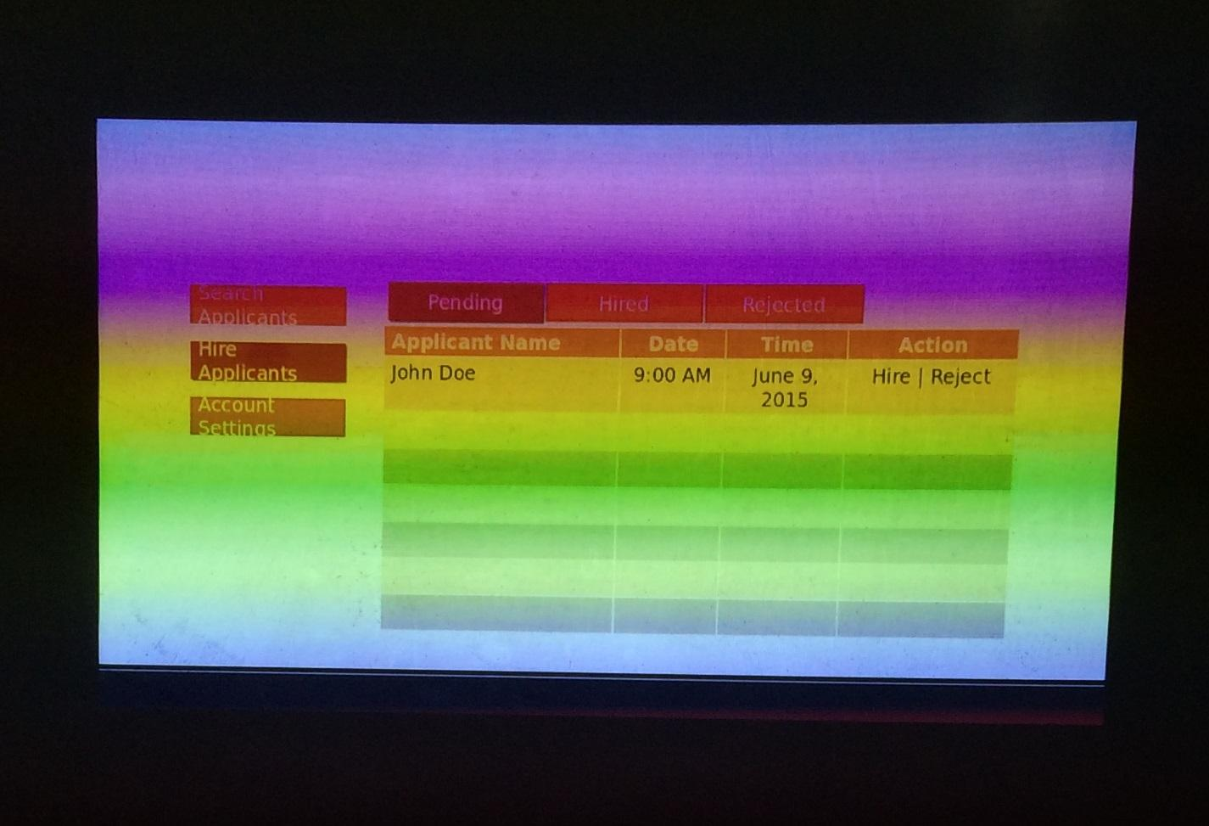

*C-1. Customer Profile Form*

*The Customer Profile Form is filled up by an account executive for each new customer that he/she brings in to the company. This is submitted to the Accounting Office who manages all customer records of the company.*



*<copy of sample form here...>*

*C-2. Weekly Sales Report*

*The Weekly Sales Report*

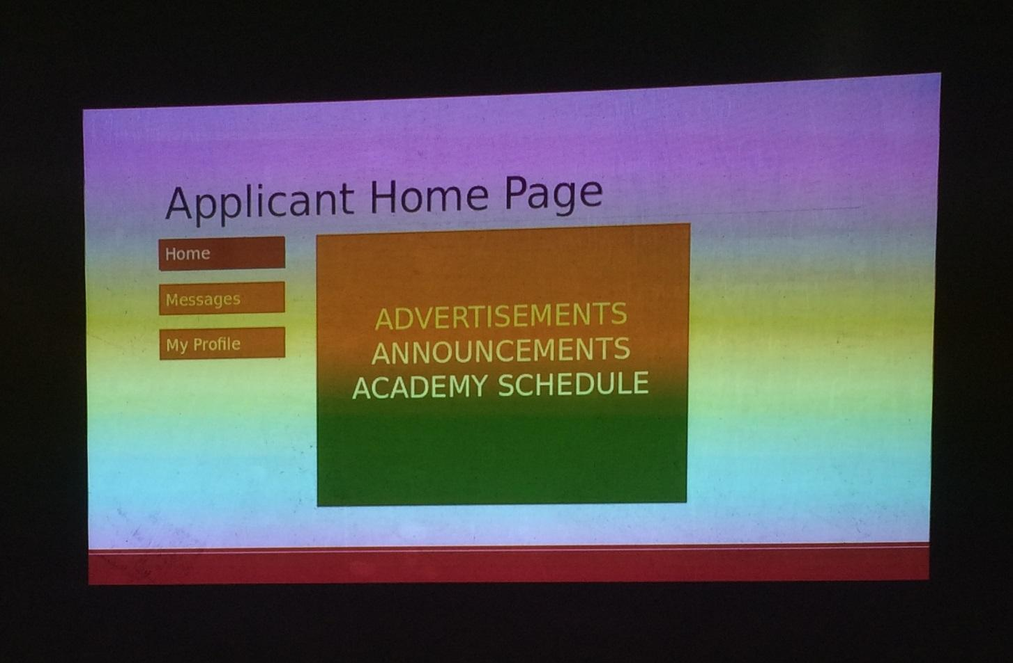

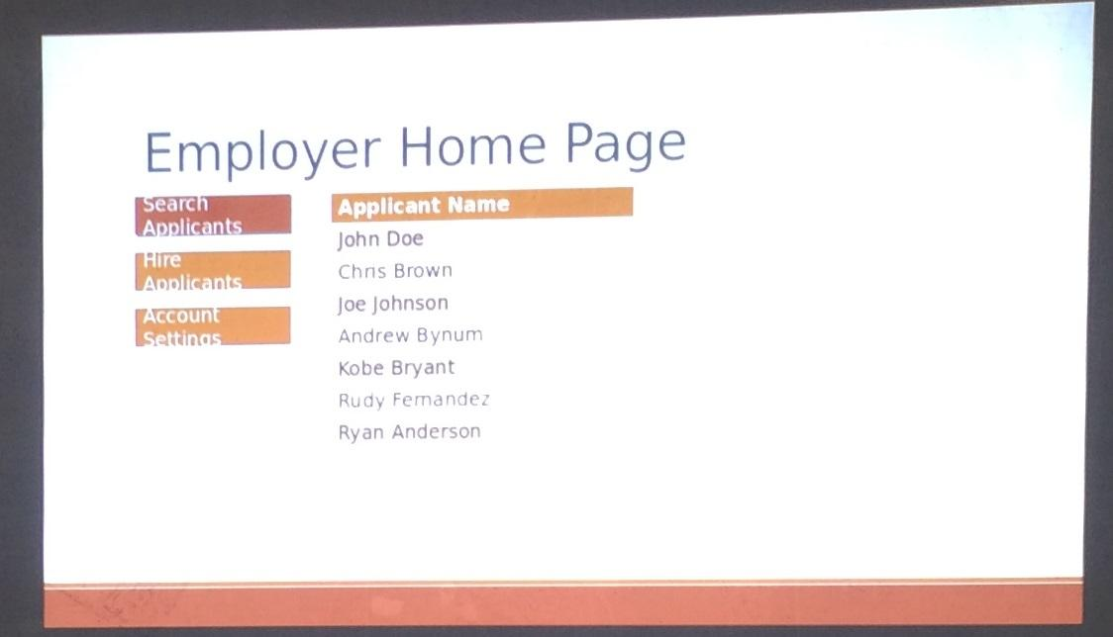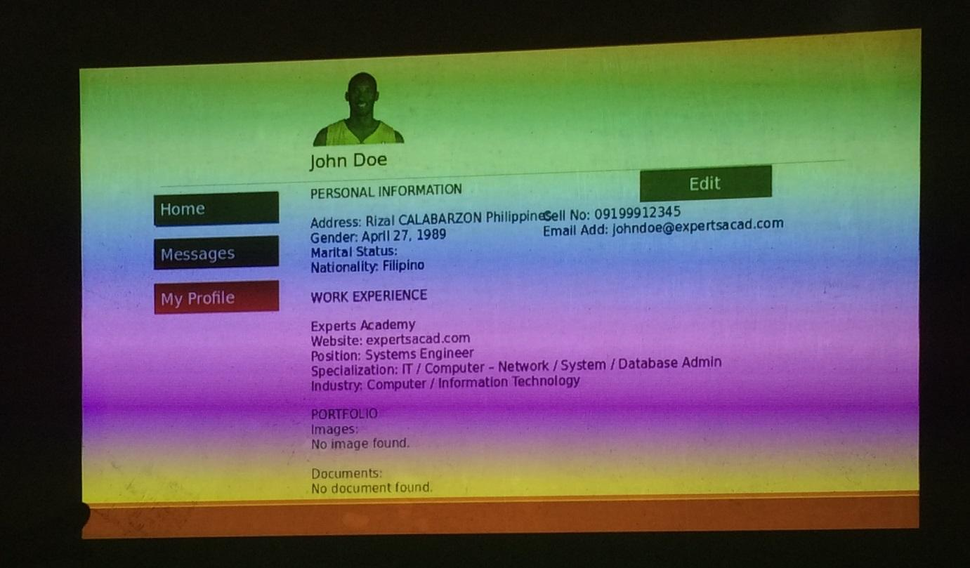

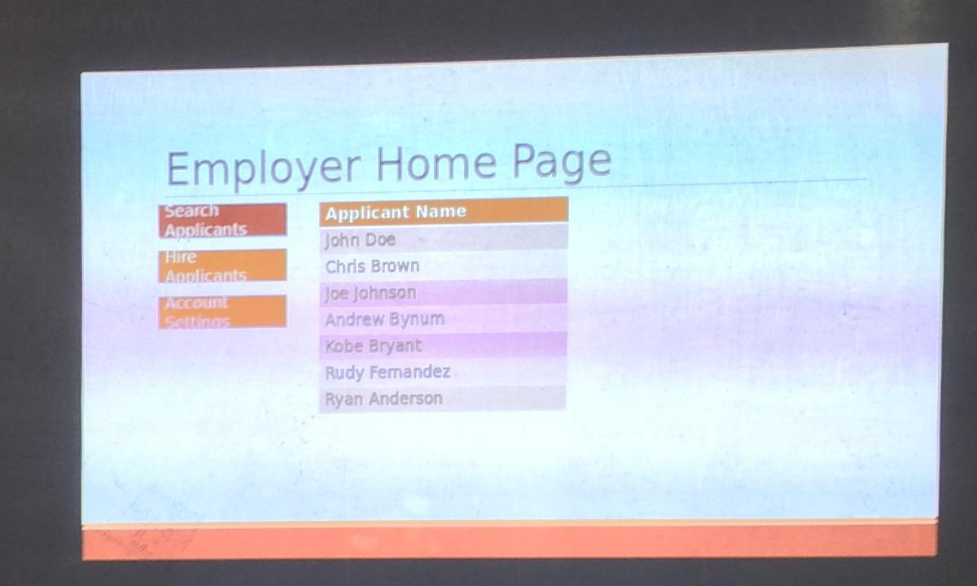

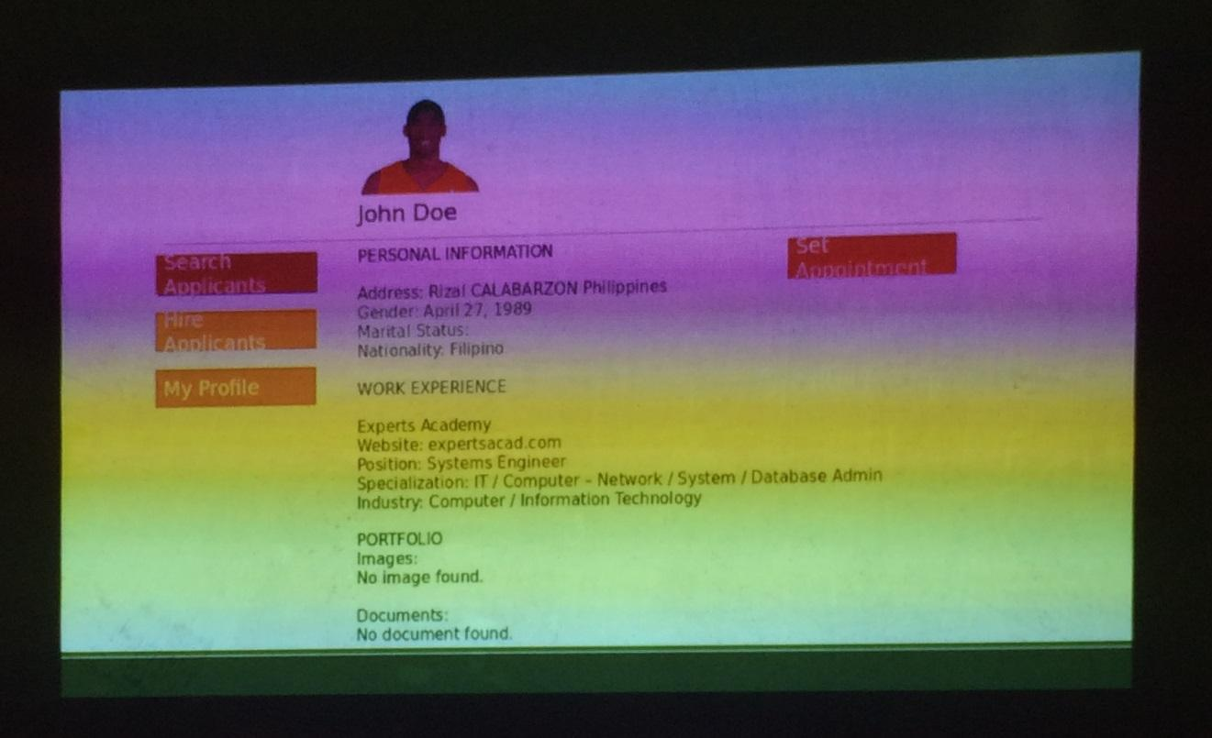

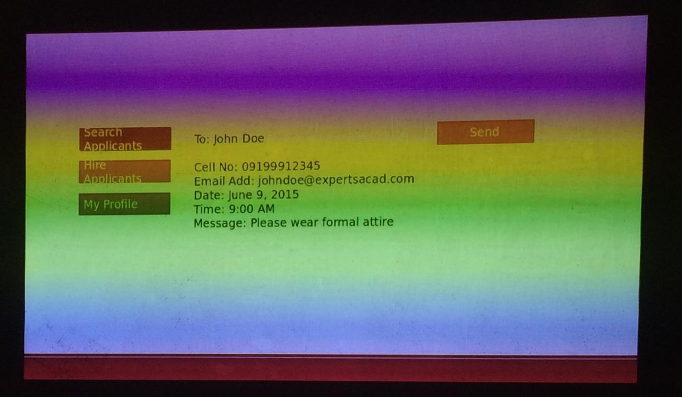

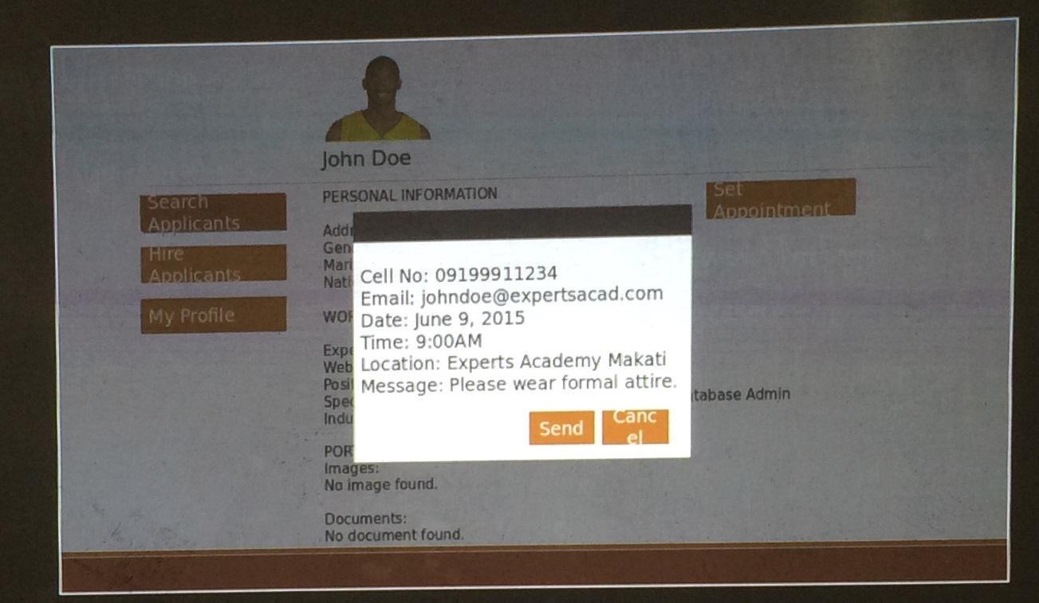

**Appendix D – References and Acknowledgement**

### This section allows you to properly cite all materials that you used, be these in the form of books or online resources. You must also acknowledge any person(s) and/or organization(s) you have interviewed or gathered the information from (name, position).